Bug Club Active Learn (Parent/carer help sheet)

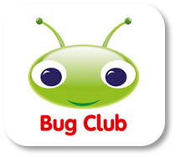

Each pupil has been assigned a username and password for Active Learn from their class teacher. This sheet has been created to help you access Bug club at home.

Locate Active Learn through google.

* Type in username and password
* Type in school code lcj6

\**If you do not gain immediate access to the resource, you must unblock popups on your computer as this may prevent you from using the resource correctly. To unblock popups locate the red ‘x’ at the top right hand corner of the screen, click on this and click ‘always allow popups’.*

**Home Page**

Once you have logged in, click on *My Stuff* to see all the resources assigned to you.

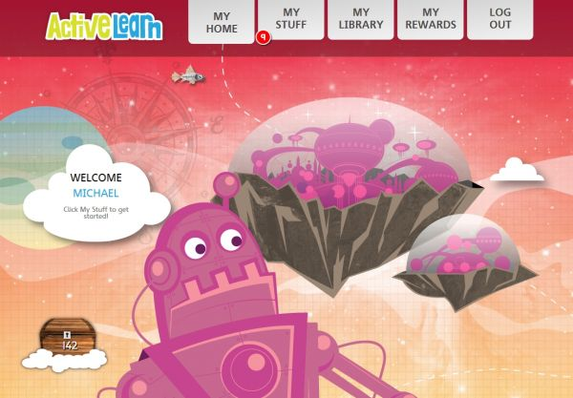

Rewards

You can see the number of **ActiveLearn** [coins](https://www.activelearnprimary.co.uk/help?s=glossary-coin) you have earned on the barrel underneath your name.

**My Stuff**

This panel contains items your teacher has set.

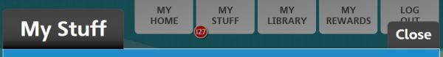

The number of items available for each programme is shown at the top right of the panel.

Items not opening?

If your items are not opening when you click on them, ask a teacher or parent to disable the Pop-up Blocker in your internet browser, using [these instructions](https://www.activelearnprimary.co.uk/help?s=information-pop-up_blocker_settings).

Activities

Your teacher will decide when activities are removed from *My Stuff*.

Activities you opened before can be found in [*My Library*](https://www.activelearnprimary.co.uk/help?s=student-my_library).

Click on the Bug head icon to open an activity. Some activity questions are unmarked and don’t require a correct answer. For these questions, the pop-up screen will thank you for your answer.

In most books, the "Done" button will be greyed out to show the activity question is complete. Click the orange arrow icon in the bottom right corner to return to the book.

The Bug head icon will have closed eyes to show that the activity has been answered. If all the Bug eyes are not closed, you can select "Keep reading" and click the "Back" arrow until you reach the book page to try that activity again. Click "Close book" to go back to your *My Stuff* page.

Books

Each [book](https://www.activelearnprimary.co.uk/help?s=glossary-book) shows a number in a yellow circle. These are the maximum reward [coins](https://www.activelearnprimary.co.uk/help?s=glossary-coin) in the book.

Get coins by reading the book and (for some books) by [completing](https://www.activelearnprimary.co.uk/help?s=glossary-complete) the [activities](https://www.activelearnprimary.co.uk/help?s=glossary-activity) inside. Spend them in [*My Rewards*](https://www.activelearnprimary.co.uk/help?s=student-my_rewards).

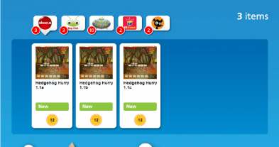

**Bug Club Books**

Click on a book to open it. Books will look slightly different depending on your book band level.

**Inside all book bands, you can:**

• Move around the book with the **blue arrows**

• Click the **magnify button** on the bottom left to zoom in

• Click the **red cross button** on the bottom right to close the book

• Click on words in **bold text** to see a definition

• Open book activities using the Bug Head icon.

**Only lower book bands:**

• Click **"Read to me"** to hear the page.

**Only higher book bands:**

• Click the **"Contents" button** to find a particular chapter, page or activity

• Click the **single page view button** to see one page at a time.

When you finish a book, it is moved to [*My Library*](https://www.activelearnprimary.co.uk/help?s=student-my_library). A book is not finished until you have completed all the activities in the book and read to the final page. This is when you get your **ActiveLearn** coins.

When a teacher views the book, it will look slightly different.

**As well as all the things that a pupil can do, a teacher can also**:

• Click on the annotation button on the bottom left to annotate the book (annotations will not save when you close the book)

• Click on the Bug Head button on the bottom left to hide all the activity icons in the book

**Bug Club Plays to Read**

Some **Bug Club** books are plays that you can read along with. When you open these, they will look just like other books, but when you turn the page you will see this:

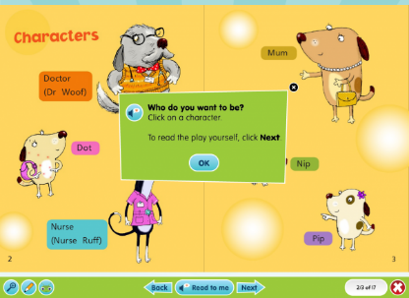

Click “OK” then click on the character that you would like to play:

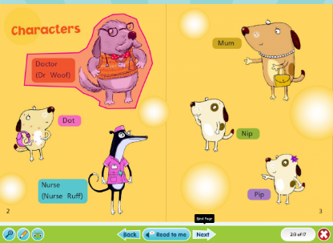

You will hear all the other characters read out. When it comes to a line by your character, the line will be highlighted. Read your line, then click “Done” to carry on:

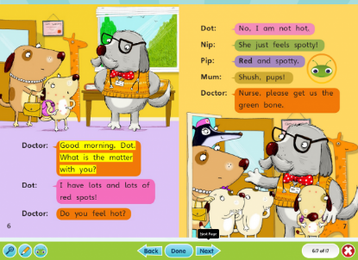

Everything else in these books works in the same way as in other **Bug Club** books.

**Note:** If you wish to use the read-along functionality in **Internet Explorer**, you will need **Version 10 or above**. IE 9 does not support the read-along functionality.

**Rapid Books**

Click on a book or activity to open it:

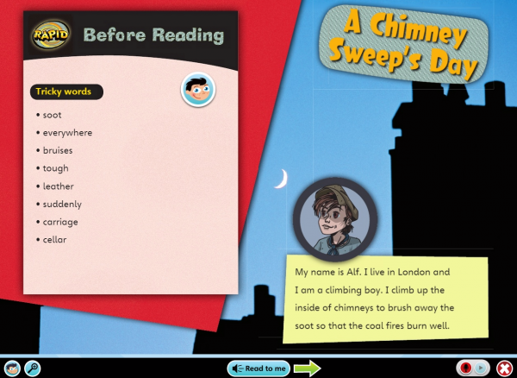

Inside the book you can:

* Move around the book with the **green arrows**.
* Click on words to hear them read out.
* Click "**Read to me**" to hear the page.
* Click the **magnify button** on the bottom left to go full screen.
* Click the **red cross button** on the bottom right to close the book.
* [Record yourself](https://www.activelearnprimary.co.uk/help?s=student-recording) using the **red microphone button**.
* Open book activities using the **Rapid Boy/girl** icon (see below).

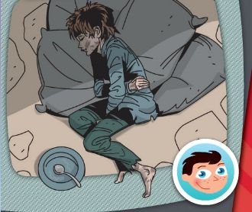

When you finish a book it is moved to *My Library*. A book is not finished until you have opened all the activities in the book.

**Wordsmith Books**

Click on a book to open it:

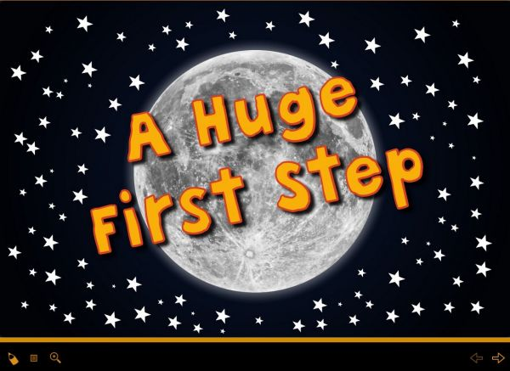

Inside the book you can:

* Move around the book using the orange arrows.
* Click the Click the **magnify button** on the bottom left to go full screen.
* Click the **red cross** button on the bottom right to close the book.
* Click the pen tool to annotate the page. (Annotations are not saved when you close the book).

Inside non-fiction books you can also:

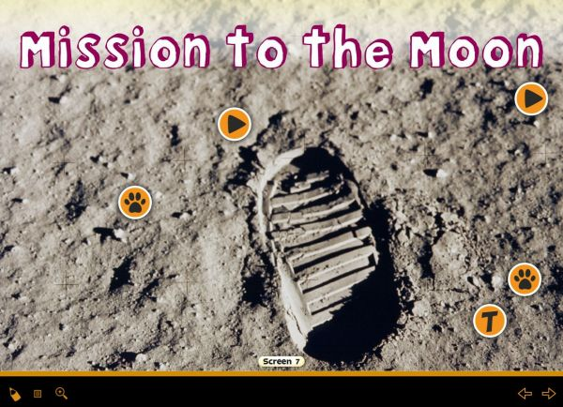

* Click on a Paw Print to open pop-up windows containing extra information such as maps, diagrams and photo slideshows
* Click on the "Play" arrow to play a video or animation
* Click the "T" button to open up an extra piece of text.

Units

Each **Grammar and Spelling Bug** [unit](https://www.activelearnprimary.co.uk/help?s=glossary-unit) shows a number. These are the maximum reward coins in the unit.

Get coins by completing the activities in the unit and getting answers correct on your first attempt. Spend them in [*My Rewards*](https://www.activelearnprimary.co.uk/help?s=student-my_rewards).

Click on a unit to open it:

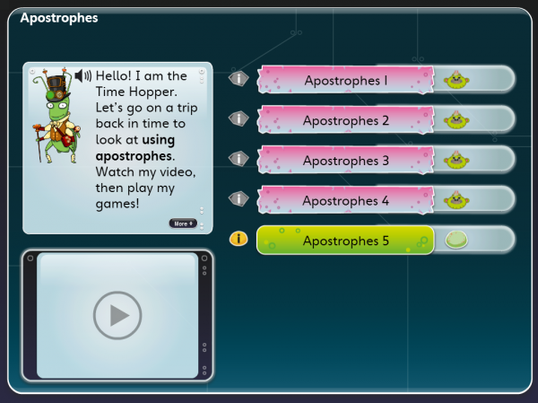

Within a unit, you can:

• Click on the **“Play” icon** in the TV screen to watch a video about the unit

• Click on the **“i” information button** beside each game to see what it is about

• Click on the **game buttons** to play the games

• Click **“Finish”** once you have played all the games, to complete the unit

• In Year 1 and Year 2, you can click on the **audio speaker button** to listen to instructions.

Web Links

You might see something that looks like this in your *My Stuff*:

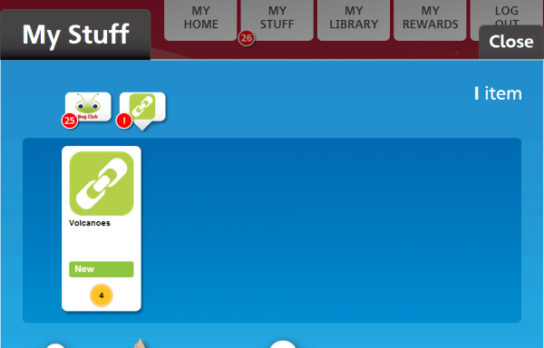

This means that your teacher has sent you a link to another website that they would like you to look at. Click on the link to go to the website. You will earn [coins](https://www.activelearnprimary.co.uk/help?s=glossary-coin) for opening the link.

**My Library**

*My Library* contains all the [books](https://www.activelearnprimary.co.uk/help?s=glossary-book) you have read and [units](https://www.activelearnprimary.co.uk/help?s=glossary-unit) that you have finished.

It also contains [activities](https://www.activelearnprimary.co.uk/help?s=glossary-activity) that you have finished or opened, but which are no longer set by your teacher.

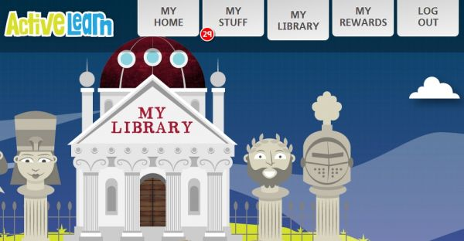

Click on the door of the library to look inside. Click on an item to open it.

**Bug Club** books appear in *My Library* once you have completed them.

**My Rewards**

*My Rewards* contains any [rewards](https://www.activelearnprimary.co.uk/help?s=glossary-reward) you have gained. You get coins when you complete [books](https://www.activelearnprimary.co.uk/help?s=glossary-book) and [activities](https://www.activelearnprimary.co.uk/help?s=glossary-activity) in [*My Stuff*](https://www.activelearnprimary.co.uk/help?s=student-my_stuff).

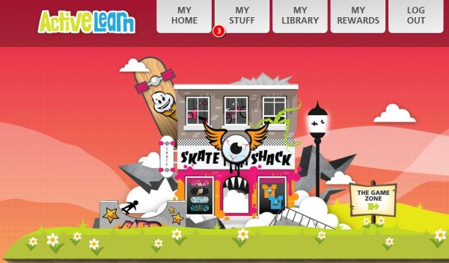

You can spend your [coins](https://www.activelearnprimary.co.uk/help?s=glossary-coin) in the Rewards areas.

Rewards areas

Click on the sign posts to move between the Rewards areas. Click on the door to look inside your chosen Rewards area.

Buying rewards

**Pit Stop**

Select a racer, and click "Race now". Race entry costs 12 coins.

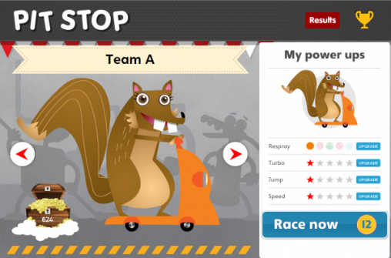

The next window to appear will explain the controls.

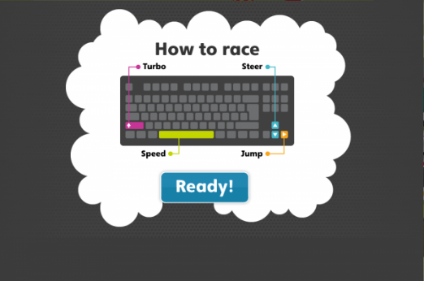

Race and enjoy.

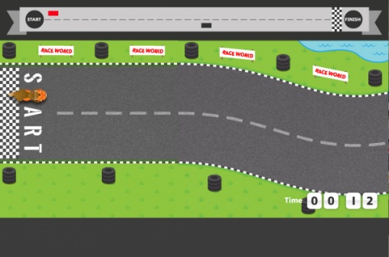

**Skate Shack**

To buy a reward, click on the item you want to change. Here we clicked on the helmet.

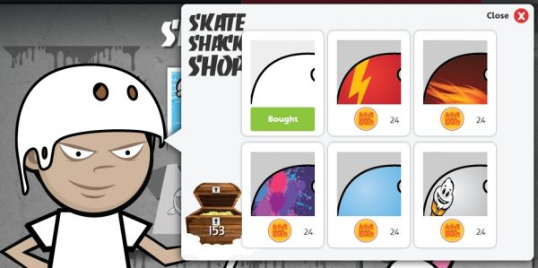

The first reward is yours for free. Items you cannot afford are grey.

To buy a different reward like a new helmet, click on it. Confirm by clicking the green tick:

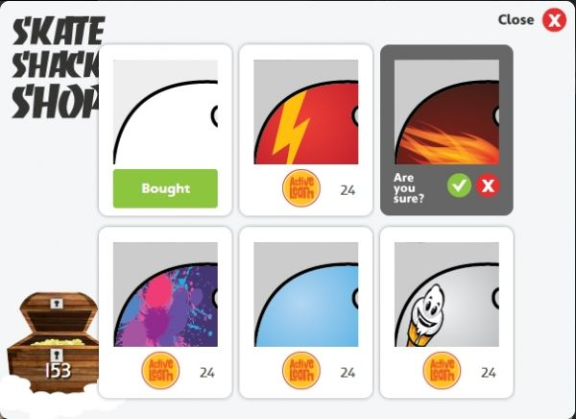

Your new reward is now added:

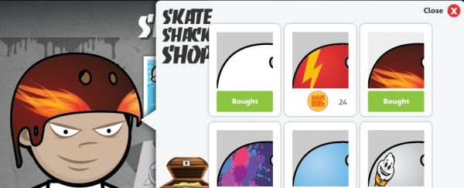

To get more coins, go to [*My Stuff*](https://www.activelearnprimary.co.uk/help?s=student-my_stuff) and start another book!

**Sticker Factory**

To buy some stickers, click "Insert 20 coins". You will then see the stickers in your pack.

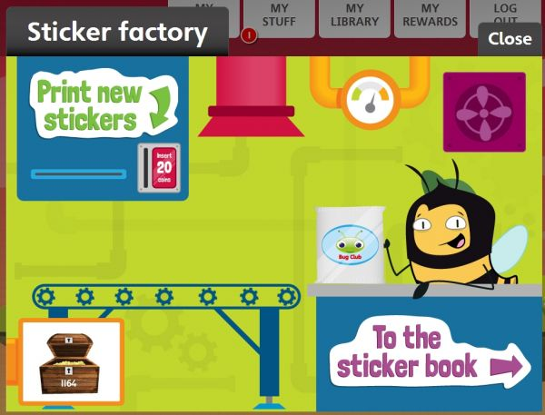

Click "To the sticker book". You can then drag and drop your stickers to the correct places in the book.

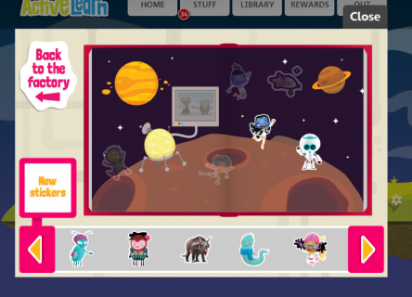

**The Game Zone**

Find the game you want to play. You will see the number of coins it costs. Click the "Play" button to spend some coins on this game.

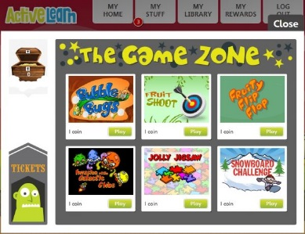

These games require **Adobe Flash Player** in order to open. This means that they will not work on a tablet device.

**The Tree House**

Add to your tree house by buying pets, furniture and toys.

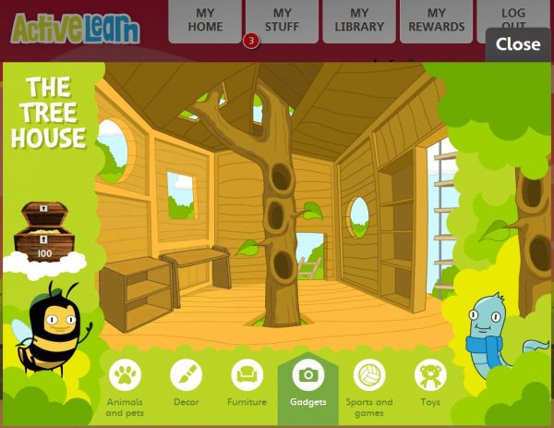

Click on the item you would like to buy. Confirm by clicking the green tick.

Items you cannot afford are grey and cannot be clicked.

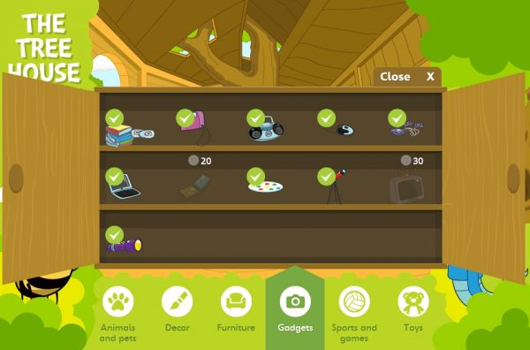

The **Grammar and Spelling Bug** units are in the library because all the [games](https://www.activelearnprimary.co.uk/help?s=glossary-game) in each unit have been completed and you have clicked “Finish” to close the unit.

The **KB Select** activities are in the library because this pupil opened them in the past and they have been removed from [*My Stuff*](https://www.activelearnprimary.co.uk/help?s=student-my_stuff) by a teacher.

The **Rapid** books below are in the library because they have all been completed. This means that the books have been read to the last page and all the activities inside the book have been finished.