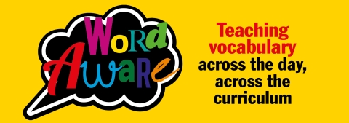
Word Aware
Dear parents and carers,
As you may know we have been using an approach called Word Aware in school to develop our children’s vocabulary. We would like this work to continue if possible when schools are closed. You may be looking for easy educational ideas to keep your children occupied!
I am therefore attaching a variety of games and activities in the hope that you might take the opportunity to play them with your child at home. The aim is to help your child have fun with words.
We know that children (and adults) who enjoy word games tend to have better vocabularies. This helps with reading and writing as well as with everyday communication.
As well as the suggested games on this list please raid your cupboards for any word related board games e.g. Boggle, Junior Scrabble, Hedbanz, Taboo, Smart chutes and Pictionary.

Thank you for your support

Claire
Claire MacLean
Speech and Language Therapist, NHS Forth Valley
Word Aware Trainer
March 2020

