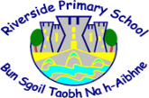

Dear New Riverside Primary Families,
We are looking forward to welcoming you and your child to Riverside Primary School!
As part of Riverside Primary’s transition, we have set up a small project for the children to do at the end of nursery and into the start of Primary 1. It is based on the book “The Colour Monster Goes To School” by Anna Llenas.
We want to find out all the things that the children love to do at nursery, at home and, after the summer, at school, as they journey from nursery to Primary 1.
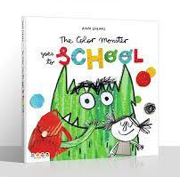
You can watch the story being read aloud by one of our teachers, Mrs Ferguson, by clicking on the image below:

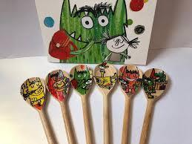
When our staff visit the children in their nurseries during the month of May, they will take little colour monster cards, which will aid a discussion with your child around their feelings about school and link in with this project.
On the next page, you will find a bank of activities you can use to engage in learning about coming to Primary 1.

Click on the title of the activity in each box to hear the songs.
The Hello Song  Help your child to learn the names of some of the children and adults they meet on visits. | Five Fat Peas  Help your child to practise fine-motor skills like doing up their coat and using cutlery, ready for school lunchtime! | Monster Feelings  Encourage your child to talk to you about their dreams and worries about starting their new adventure.
Pirate, Pirate Dressed in Blue  Talk to your child about what uniform they will be wearing at school. | Rainbow Song (with Makaton)  Talk positively to your child about different needs and strengths which children in their class may have. | Bananas Unite  Talk to children about how they will take a snack for playtime and play outside with their new friends.

Have fun with all these activities. We can’t wait to sing the songs with your child in Primary 1!
Best wishes,
The Riverside Transition Team ☺

